Game Document User Guide
Math files: H021192R.xlsx, H021194R.xlsx

I. Worksheet Function Introduction
Overview: provides the game math-value settings
- Bet
- Total RTP
- Scatter symbol appear rate: occurrence rate of the Scatter Symbol
- Window Size
- Pay Table

Parameter: provides all parameters used by the game
- Parameter
  - BaseWheel
    - After each Base Game spin, this weight determines which BaseGameSymbol is used.
  - FreeWheel
    - During Free Game, after each spin, this weight determines which FreeGameSymbol is used.
- BaseGameSymbol
  - Symbol: Base Game reel strip table
    - Select the stop position according to Weights.

  - MY Weight
    - MY1-MY8 symbols are uniformly converted into one symbol according to MY Weight.
    - MY1-MY8 symbols are mutually different symbols.
    - Example: MY1 is converted to M1. When converting MY2, the draw weight of M1 becomes 0, and so on until MY8.
    - MY1G-MY8G are the golden symbols of the corresponding converted MY symbols.
    - Only one MY conversion is required per SPIN; all subsequent cascade replenishments use the conversion result from that spin.
  - (1~4 Combn) Weight
    - Determine the cascade replenishment symbol weights according to the current number of wins/cascades.
  - Expand Weights
    - According to the current cascade count and whether a golden symbol is eliminated on R1-R5, draw with Expand / (Not Expand + Expand) probability to determine whether that reel triggers WILD expansion.
    - If multiple golden symbols are eliminated on the same reel at the same time, only one determination is performed.
    - WILD expansion is calculated as x4.
    - WILD expansion does not overwrite C1.
- FreeGameSymbol
  - Symbol: Free Game reel strip table
    - Select the stop position according to Weights.

  - MY Weight: MY1-MY8 symbols are uniformly converted into one symbol according to MY Weight.
    - MY1-MY8 symbols are mutually different symbols.
    - Example: MY1 is converted to M1. When converting MY2, the draw weight of M1 becomes 0, and so on until MY8.
    - MY1G-MY8G are the golden symbols of the corresponding converted MY symbols.
    - Only one MY conversion is required per SPIN; all subsequent cascade replenishments use the conversion result from that spin.
  - (1~4 Combn) Weight
    - Determine the cascade replenishment symbol weights according to the current number of wins/cascades.
  - Expand Weights
    - According to the current cascade count and whether a golden symbol is eliminated on R1-R5, draw with Expand / (Not Expand + Expand) probability to determine whether that reel triggers WILD expansion.
    - If multiple golden symbols are eliminated on the same reel at the same time, only one determination is performed.
    - WILD expansion is calculated as x5, x6, x8, x8, x8 according to the number of reels expanded simultaneously.
    - Example: if R2 and R3 expand simultaneously, R2 is calculated as x5 and R3 as x6.
    - WILD expansion does not overwrite C1.

Jackpot Document Description
Math files: JP01004.xlsm, JP01002.xlsm

I. Worksheet Function Introduction
Overview: records the default jackpot settings. The following information can be found here:
- Denom
- Minimum Bet
- Increment
- Base Start Up Pool after reset

List: provides parameter mapping for different regions.
- The Denom, Minimum Bet, Increment, and Start Up Pool settings differ by region.

Output_Bet1: this is the parameter table provided for the backend program to read.
- The left side of the table summarizes the Denom, Minimum Bet, Bet, Increment (%), Start Up Pool, and other information required by the current system.
- The right side of the table provides jackpot winning weights for different bets.

Setting_Bet1: provides information used for model calculations.
- This sheet shows the specific values corresponding to 1 to 30 different Bet Multipliers (bet amount and award amount).

Calculate_Bet1: model calculation (hit-rate calculation for each award).

II. Usage of Mini Game Awards Pool in the Output_Bet1 worksheet
This table is the core probability table used by the backend to determine whether a player triggers a Jackpot. The specific operating logic and usage are as follows:

1. Parameter Definitions
- Threshold : 10,000,000,000
- Mini Game Awards Pool: in the Output_Bet1 table, levels 1 to 30 are listed (corresponding to different bet multipliers), and each level has corresponding JP1-JP4 weight values.

2. Program Determination Flow (determination per Spin): when a player places a bet, the backend should perform the following steps:
- Confirm the player's bet level: determine which Index (1 to 30) in the table corresponds to the player's current bet amount.
- Fetch the corresponding weights: read the JP1-JP4 weights from the entire row of that Index.
- RNG determination: generate a random integer between 1 and 10,000,000,000 (Threshold).
- Compare the interval:
  - If the random number falls within the weight range of a certain JP, that jackpot level is determined to be triggered.
  - Example: when the player bets at level 1, the weight of JP1 is 26. If the generated random number is between 1 and 26, the player wins JP1; the actual trigger probability is 26 / 10,000,000,000.

3. Notes on Weight Design Logic: during implementation, engineers should note the following characteristics of weight changes:
- Dynamic probability: the winning weights of JP1 and JP2 increase linearly as the player's bet level rises. For example, JP1 has a weight of 26 at level 1, but reaches 650,000 at level 30. This is to give high-bet players a reasonable higher hit rate.
- Fixed probability: the weight of JP3 is always fixed at 1,600,000, and JP4 is always fixed at 12,000,000; they do not change with the bet level. The probabilities of these two smaller awards are static and mainly reflect high-bet rewards by changing the base award size (Start Up Pool).

Scatter Symbol Hit Determination Description

I. Overview
Defines the execution logic in the game "Sugar Kaboom" for converting the mathematical theoretical Jackpot hit rate (hereinafter referred to as JP) into the in-game Scatter Symbol hit determination.

II. Core Trigger Mechanism
- Trigger method: a Scatter Symbol appears on the game board.
- Determination frequency: after each Spin, if a Scatter Symbol appears at any position on the board, one jackpot winning determination is performed.

III. Hit Determination Probability Calculation
Because the math files (JP01004.xlsm, JP01002.xlsm) define the theoretical winning probability per bet, but the actual determination occurs only when a Scatter Symbol appears, the actual hit success rate must be amplified and adjusted.

- Key Variable Definitions
  - Ptheory: theoretical winning probability. This comes from the expected winning rate per bet calculated from the Threshold or RTP in the math files.
  - Pscatter: Scatter Symbol occurrence rate. This is the probability that at least one Scatter Symbol appears on the board in each Spin.
  - Phit: actual hit success rate. This is the success threshold used by the backend random draw after detecting a Scatter Symbol.

- Conversion Formula
  - Phit = Ptheory / Presipn
Example:
If Ptheory is 0.1% and the probability of a Scatter Symbol appearing per spin, Presipn, is 10%, then when a Scatter Symbol appears, the hit success rate for that determination should be set to 1% (0.1% / 10%) to ensure the long-term total return rate meets expectations.

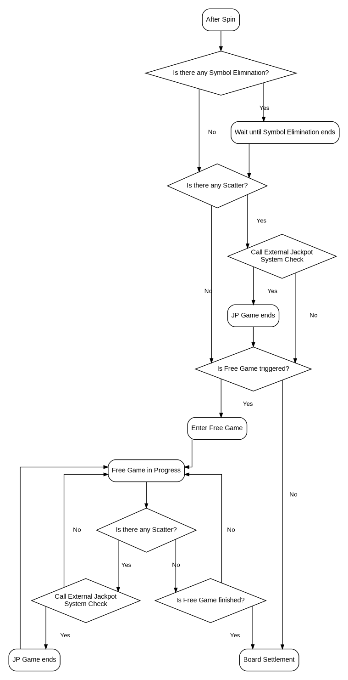
Game Flow

